**EXPERIMENT NO:-6**

* **AIM:** To Design and test decoder circuit.

* **APPARATUS:** Trainer kit, connecting wires

* **THEORY:**

Discrete quantities of information are represented in digital systems with binary codes. A binary code of n bits is capable of representing up to 2^n distinct elements of the coded information. A decoder is a combinational circuit that converts binary information from n input lines to a maximum of 2^n unique output lines. If the n-bit decoded information has unused or don’t-care combinations, the decoder output will have less than 2^n outputs.

The decoders presented here are called n-to-m line decoders where m<=2^n. Their purpose is to generate the 2^n (or less) minterms of n input variables. The name decoder is also used in conjunction with some code such as BCD-to seven -segment decoder.

Consider the 3 to 8 line decoder circuit. The three inputs are decoded into eight outputs. Each output representing one of the minterms of the 3-input variables. The three inverters provide the complement of the outputs, and each one of eight AND gates generate one of the minterms. A particular application of this decoder would be a binary to octal conversion. The input variables may represent a binary number, and the outputs will then represent the eight digits in the octal number system. However a 3-to-8-line decoder can be used for decoding and 3-bit code to provide eight outputs, one for each element of the code.

CIRCUIT DIAGRAM OF 3 TO 8 BIT DECODER:

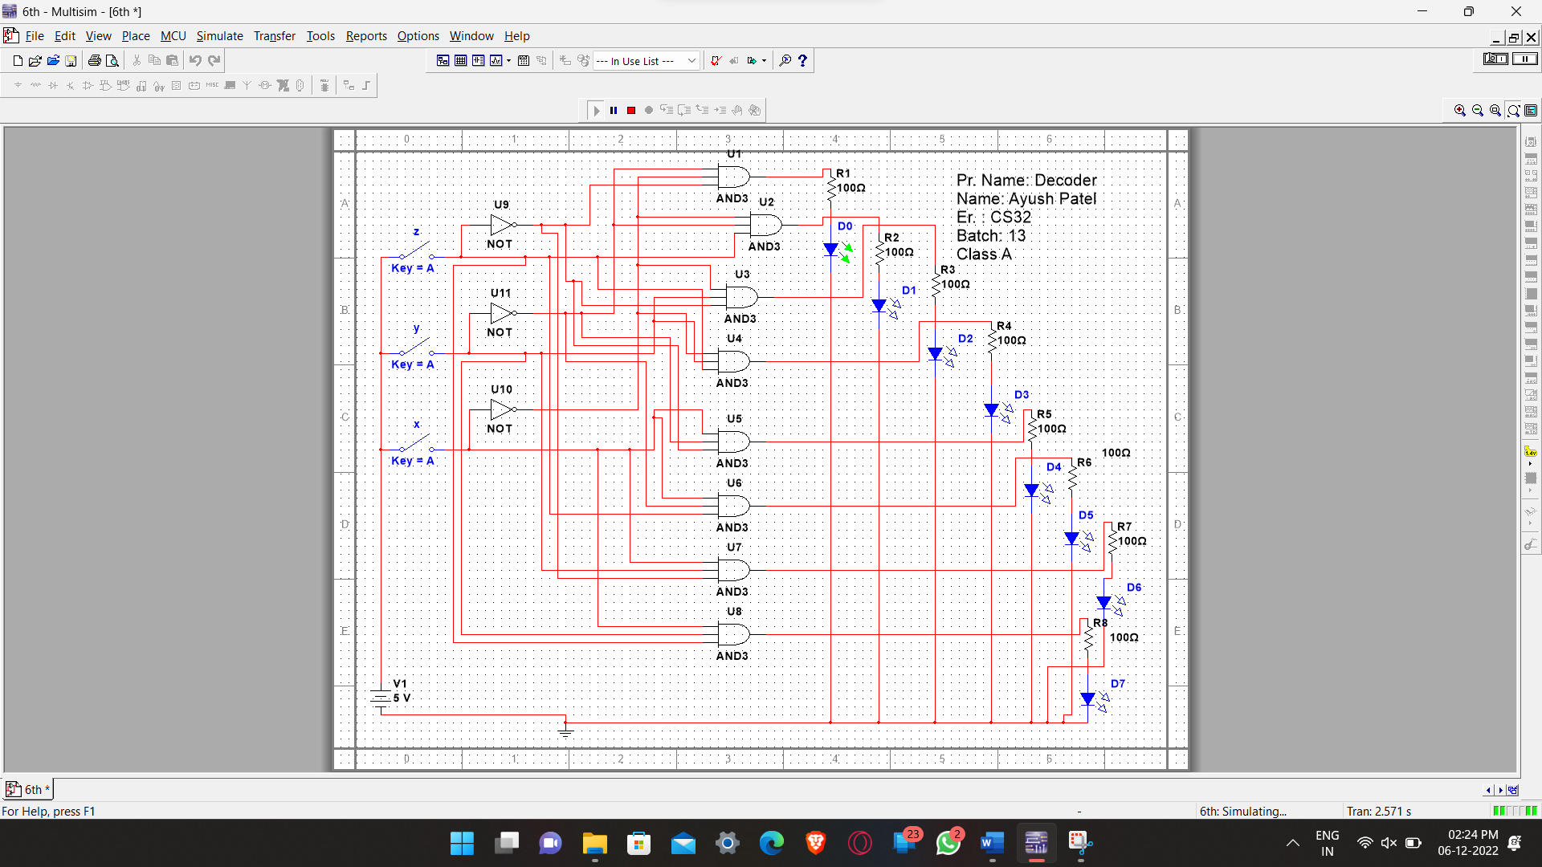

TRUTH TABLE OF 3 TO 8 BIT DECODER:

|  |  |  |  |  |  |  |  |  |  |  |  |
| --- | --- | --- | --- | --- | --- | --- | --- | --- | --- | --- | --- |
| **INPUTS** | | | |  |  |  | **OUTPUTS** | |  |  |  |
| **ENABLE** | **ADDRESS**  **LINES** | | |
| EN | A0 | A1 | A2 | Y7 | Y6 | Y5 | Y4 | Y3 | Y2 | Y1 | Y0 |
| 1 | 0 | 0 | 0 | 0 | 0 | 0 | 0 | 0 | 0 | 0 | 1 |
| 1 | 0 | 0 | 1 | 0 | 0 | 0 | 0 | 0 | 0 | 1 | 0 |
| 1 | 0 | 1 | 0 | 0 | 0 | 0 | 0 | 0 | 1 | 0 | 0 |
| 1 | 0 | 1 | 1 | 0 | 0 | 0 | 0 | 1 | 0 | 0 | 0 |
| 1 | 1 | 0 | 0 | 0 | 0 | 0 | 1 | 0 | 0 | 0 | 0 |
| 1 | 1 | 0 | 1 | 0 | 0 | 1 | 0 | 0 | 0 | 0 | 0 |
| 1 | 1 | 1 | 0 | 0 | 1 | 0 | 0 | 0 | 0 | 0 | 0 |
| 1 | 1 | 1 | 1 | 1 | 0 | 0 | 0 | 0 | 0 | 0 | 0 |

➢ **PROCEDURE:**

1. First of all apply any combination of 3-bit input.
2. Keep the EN1 to high and EN2 to low according to the data sheet.
3. Now give all the output Q0 to Q7 to the output indicator LED and verify the truth table.

* **CONCLUSION:**

Here we can say that when we give 0,0,0 input in output only LED D0 will glow